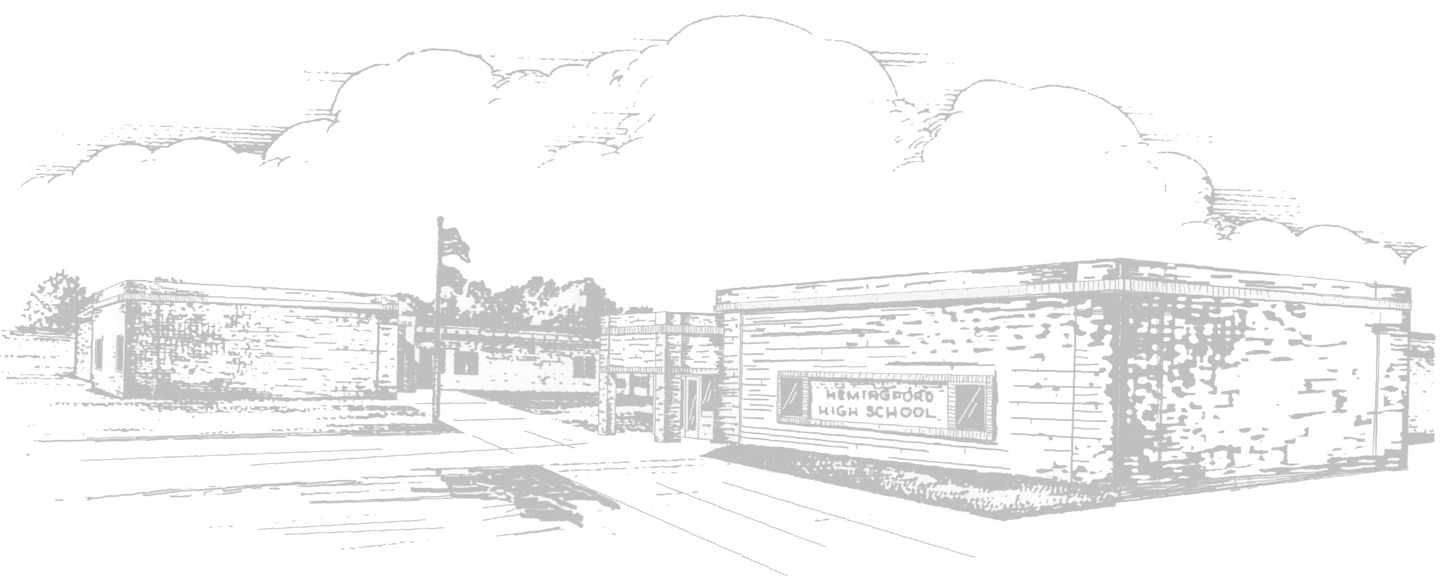 |  | Hemingford Public Schools  Breakfast Menu
January |  | Milk is served with all meals: Alternative either hot or cold cereal offered every day.
Monday | Tuesday |  | Wednesday | Thursday | Friday
1 | 2  Teacher  In-Service |  | 3  French Toast  Sausage or Cereal  Fruit/Juice | 4  Breakfast Casserole or PBJ  Fruit/Juice | 5  Breakfast Sandwich or Cereal  Fruit/Juice
8  Pancakes  Sausage or Cereal  Fruit/Juice | 9  Scrambled Eggs  Muffin or PBJ  Fruit/Juice |  | 10  Waffles N’  Strawberries or Cereal  Fruit/Juice | 11  Breakfast Pizza  Or PBJ  Fruit/Juice | 12  Breakfast Burrito or Cereal  Fruit/Juice
15  Biscuits N’ Gravy or Cereal  Fruit/Juice | 16  Omelet & Toast  Or PBJ  Fruit/Juice |  | 17  French Toast  Sausage or Cereal  Fruit/Juice | 18  Breakfast Casserole or PBJ  Fruit/Juice | 19  Breakfast Sandwich or Cereal  Fruit/Juice
22  Pancakes  Sausage or Cereal  Fruit/Juice | 23  Scrambled Eggs  Muffin or PBJ  Fruit/Juice |  | 24  Waffles N’  Strawberries or Cereal  Fruit/Juice | 25  Breakfast Pizza  Or PBJ  Fruit/Juice | 26  Breakfast Burrito or Cereal  Fruit/Juice
29  Biscuits N’ Gravy or Cereal  Fruit/Juice | 30  Omelet & Toast  Or PBJ  Fruit/Juice |  | 31  French Toast  Sausage or Cereal  Fruit/Juice
Menus are subject to change
USDA is an equal opportunity provider & employer.
The Hemingford Public School provides lunches in accordance with the National School Lunch Program.
The cost of a breakfast is as follows: PreK-12 - $1.55 Adult Breakfast - $2.05
The cost of a lunch is as follows: PreK - $2.05 K-6 Lunch - $2.30 7 - 12 Lunch - $2.60 Adult Lunch - $3.75

