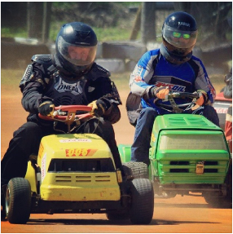
Lawn Mower Races
are coming to
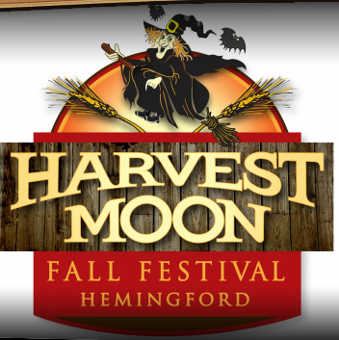
Box Butte County Fairgrounds.
Saturday,October 18th
Racing Starts at NOON.
Pits open at 10 am.
Cost:

Grandstand: A non-perishible food item or a free will donation.
Pits: $5, (Money will be used to support racers.)
This is a fundraising activity to support Hemingford Wrestlers, and the local food bank. Come out, support your racers, support your wrestlers, and support your community in the action filled event. Money will be used to purchase new wrestling equipment at Hemingford High School. The food items collected will be donated to the local food bank.

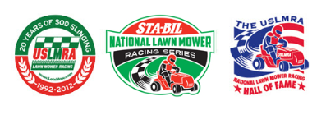
Interested in Racing?
Check out the rules at: www.LETSMOW.COM
Racing classes will include: BP, JP, IMOW & GP
Contacts:
Technical questions about mowers: Casey Eaton, caseyeaton@hotmail.com
Questions about event: Peter Gomez, picgom6@gmail.com

