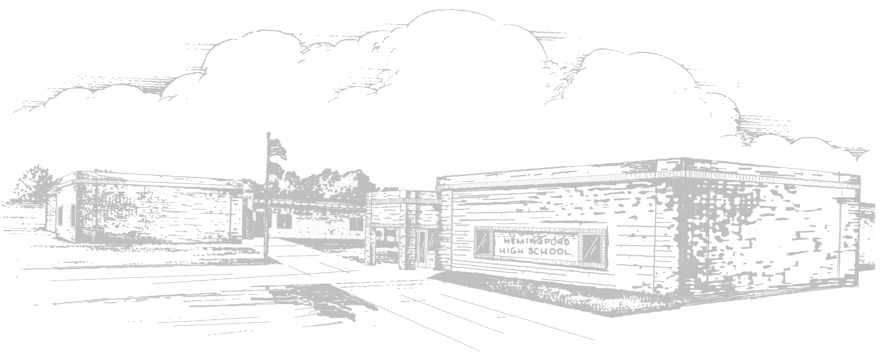 |  | Hemingford Public Schools  Lunch Menu
January |  | Milk is served with all meals. Fruit/Salad/Vegetable Bar Offered Daily
Monday | Tuesday |  | Wednesday | Thursday | Friday
1 | 2  Teacher  In-Service |  | 3  Frito Pie  Broccoli | 4  Chicken Bowls  Dinner Roll | 5  Hamburgers  Fries/Tots  Cookie
8  Pepperoni Stromboli  Corn | 9  Sweet N’ Sour Chicken  Rice  Green Beans |  | 10  Goulash  Cheese Breadsticks  Peas | 11  Salisbury Steak  Mashed Potato  Dinner Roll | 12  Beefy Nacho  Carrots  Apple Crisp
15  Beef N’ Cheddar on Bun  Corn | 16  Chicken N’ Noodles over Mashed Potato  Dinner Roll |  | 17  Chuckwagon Stew  Biscuit | 18  Chicken Strips  Green Beans | 19  Tomato Soup  Grilled Cheese  Chocolate  Sheetcake
22  Turkey Gravy over Mashed Potato  Dressing | 23  Pulled Pork Sandwich  Baked Beans |  | 24  Beef N’ Noodles  Mashed Potato  Dinner Roll | 25  Terriyaki Chicken over Rice  Broccoli | 26  Chili  Carrots/Celery  Cinnamon Roll
29  Chicken Bacon Ranch Flatbread  Green Beans | 30  Taco  Spanish Rice |  | 31  Chicken Enchiladas  Refried Beans
Menus are subject to change
USDA is an equal opportunity provider & employer.
The Hemingford Public School provides lunches in accordance with the National School Lunch Program.
The cost of a breakfast is as follows: PreK-12 - $1.55 Adult Breakfast - $2.05
The cost of a lunch is as follows: PreK - $2.05 K-6 Lunch - $2.30 7 - 12 Lunch - $2.60 Adult Lunch - $3.75

