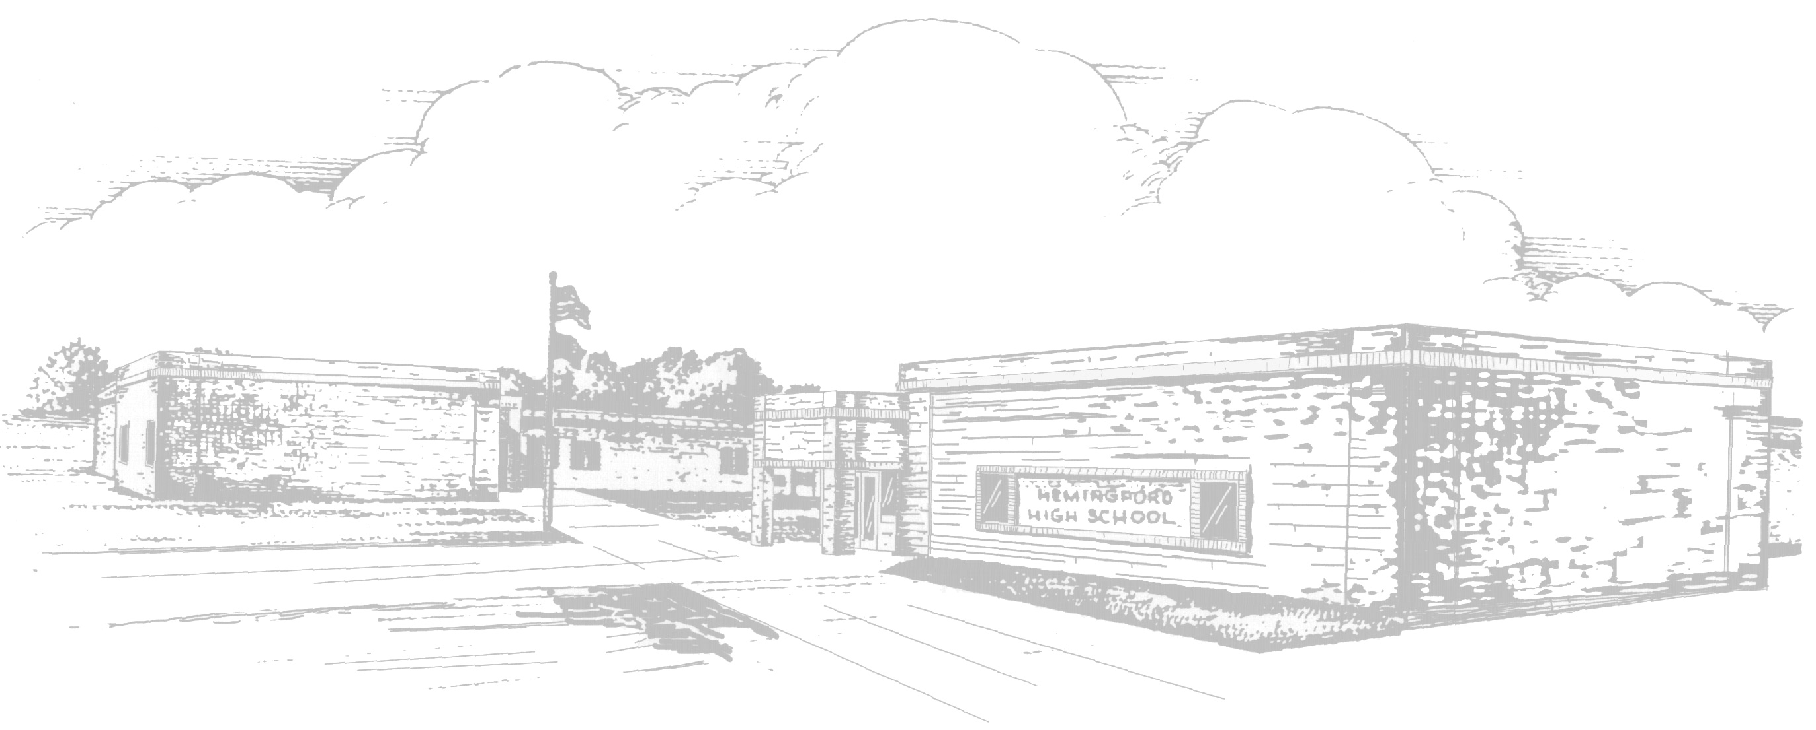 |  | Hemingford Public Schools  Lunch Menu
January 2012 |  | Milk is served with all meals
Monday | Tuesday |  | Wednesday | Thursday | Friday
  2 | 3  HAMBURGER  French Fries  Pineapple  Dill Slices  SALAD BAR&  Potato Soup |  | 4  FRITO PIE  Green Beans  Fruit Cocktail  Roll & Butter  SALAD BAR | 5  CHICKEN  STRIPS  Carrots  Peaches  Roll & Butter  SALAD BAR &  Beef Barley Soup | 6  SPAGHETTI  Coleslaw  Pears  Garlic Bread  SALAD BAR
9  CHICKEN  FRIED STEAK  Mashed Potatoes  Peaches  Roll & Butter  SALAD BAR | 10  MAC & CHEESE  Green Beans  Fruit Cocktail  Roll & Butter  SALAD BAR&  Broc.Cheese |  | 11  CRISPITO  Lettuce Salad  Pears  Roll & Butter  SALAD BAR | 12  CHICKEN  NUGGETS  Mixed Veg.  Fresh Fruit  Roll & Butter  SALAD BAR&  Chicken Noodle | 13  CORNDOG  Carrots  Apple Crisp  Roll & Butter  SALAD BAR
16  PIG in a  BLANKET  Baked Beans  Applesauce  No Bake Cookie  SALAD BAR | 17  BEEFY NACHOS  Lettuce Salad  Pears  Roll & Butter  SALAD BAR&  Italian Wedding  Soup |  | 18  BURRITO  Green Beans  Fresh Fruit  Roll & Butter  SALAD BAR | 19  GRILLED  CHEESE  Carrots  Fruit Cocktail  Tomato Soup  SALAD BAR&  Tomato Soup | 20  PIZZA  Corn  Peaches  Pudding  SALAD BAR
23  CHICKEN&  NOODLES  Green Beans  Pineapple  Roll & Butter  SALAD BAR | 24  CHILI  Carrots& Celery  Applesauce  Cinnamon Roll  SALAD BAR&  Bean& Bacon  Soup |  | 25  ITALIAN  DUNKERS  Corn  Pears  Dipping Sauce  SALAD BAR | 26  CHICKEN  SANDWICH  Carrots  Fresh Fruit  SALAD BAR&  Cheesy Tortilla  Soup | 27  TACO’S  Refried Beans  Peaches  Roll& Butter  SALAD BAR
30  HOT HAM&  CHEESE  French Fries  Fruit Cocktail  SALAD BAR | 31  CHICKEN  STRIPS  Green Beans  Fresh Fruit  Roll& Butter  SALAD BAR&  Chicken&Dump.
Menus are subject to change
This facility is operated in accordance with U.S. Department of Agriculture policy which does not permit discrimination because of race, color, sex, age, handicap, or national origin. More information may be obtained here or from the Office of Equal Opportunity, USDA, Washington, D.C. 20250. Any person who believes that he or she has been discriminated against in any USDA- related activity should write immediately to the Secretary of Agriculture, Washington, D.C. 20250.
The Hemingford Public School provides lunches in accordance with the National School Lunch Program.
The cost of a breakfast is as follows: PreK-12 - $1.15 Adult Breakfast - $1.65
The cost of a lunch is as follows: PreK - 6 Lunch - $1.65 7 - 12 Lunch - $1.95 Adult Lunch - $2.75

