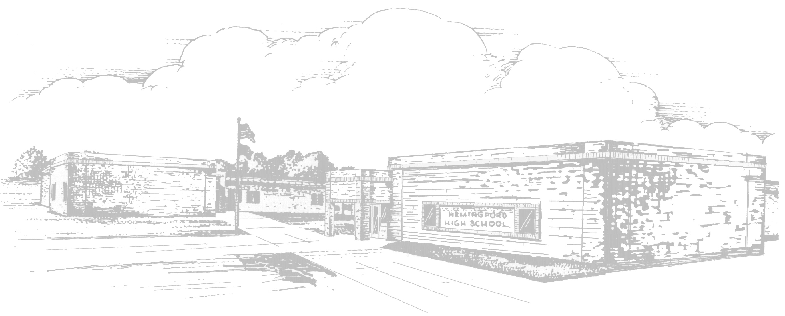 |  | Hemingford Public Schools  Breakfast Menu
January 2012 |  | Milk is served with all meals
Monday | Tuesday |  | Wednesday | Thursday | Friday
  2 | 3  CEREAL  Fruit or Juice |  | 4  PANCAKES  Fruit or Juice | 5  BREAKFAST  TAC-GO  Fruit or Juice | 6  BREAKFAST  PIZZA  Fruit or Juice
9  CEREAL  Fruit or Juice | 10  PANCAKE &  SAUSAGE on a  STICK  Fruit or Juice |  | 11  BREAKFAST  PIZZA  Fruit or Juice | 12  OMELET  Tater Tots  Fruit or Juice | 13  CINNAMON  ROLL  Fruit or Juice
16  CEREAL  Fruit or Juice | 17  WAFFLES  Fruit or Juice |  | 18  CEREAL  Fruit or Juice | 19  FRENCH  TOAST STICKS  Fruit or Juice | 20  BREAKFAST  PIZZA  Fruit or Juice
23  CEREAL  Fruit or Juice | 24  SAUSAGE  GRAVY/  Biscuit  Fruit or Juice |  | 25  BREAKFAST  PIZZA  Fruit or Juice | 26  SCRAMBLED  EGGS  Tater Tots  Fruit or Juice | 27  CINNAMON  ROLL  Fruit or Juice
30  CEREAL  Fruit or Juice | 31  BREAKFAST  BURRITO  Fruit or Juice
Menus are subject to change
This facility is operated in accordance with U.S. Department of Agriculture policy which does not permit discrimination because of race, color, sex, age, handicap, or national origin. More information may be obtained here or from the Office of Equal Opportunity, USDA, Washington, D.C. 20250. Any person who believes that he or she has been discriminated against in any USDA- related activity should write immediately to the Secretary of Agriculture, Washington, D.C. 20250.
The Hemingford Public School provides lunches in accordance with the National School Lunch Program.
The cost of a breakfast is as follows: PreK-12 - $1.15 Adult Breakfast - $1.65
The cost of a lunch is as follows: PreK - 6 Lunch - $1.65 7 - 12 Lunch - $1.95 Adult Lunch - $2.75

